**Name**: Gamal Sobhy Gamal – PHP Track  
**Red-Hat Adminstration Lap1**

**1.installation**

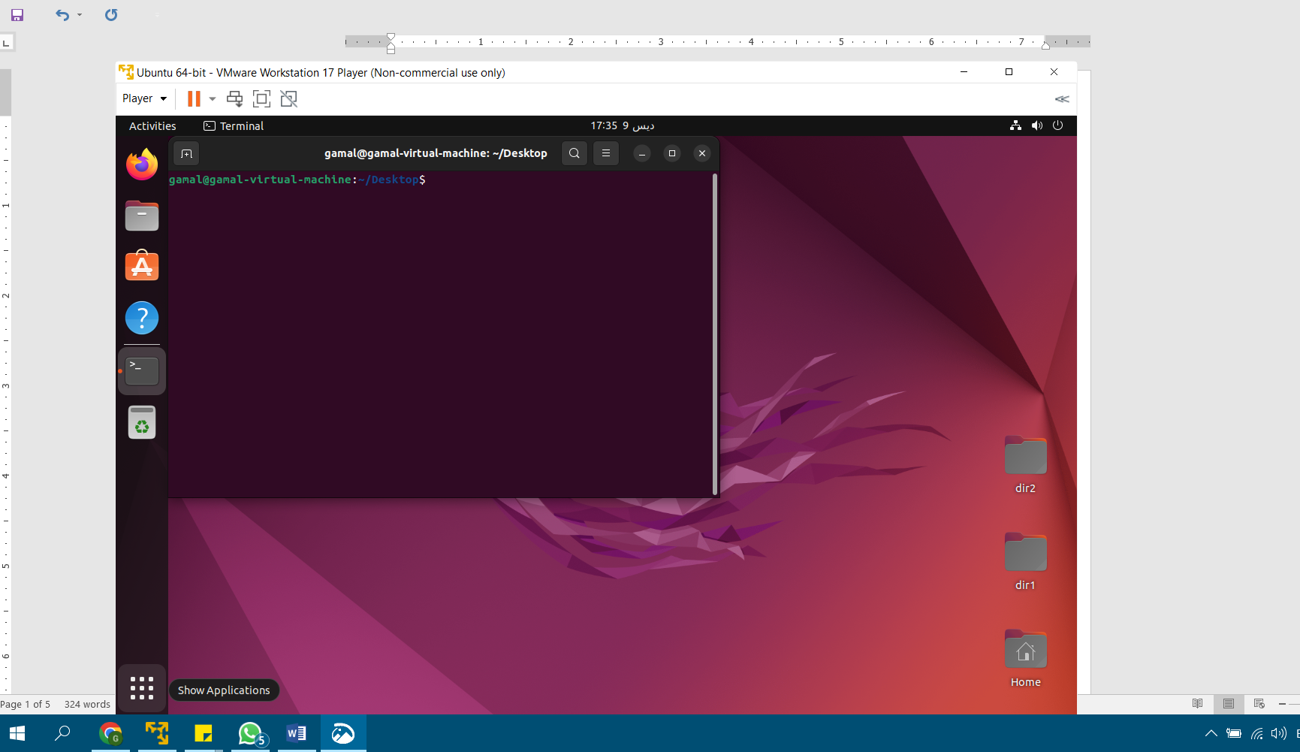

**2. What is the difference between cat and more command?**

As 'cat' command displays the file content. Same way 'more' command also displays the content of a file. Only difference is that, in case of larger files, 'cat' command output will scroll off your screen while 'more' command displays output one screenful at a time.

**3. What is the difference between rm and rmdir using man?**

There are two ways to remove directories in Linux: the rm and rmdir commands. The TL;DR of both commands is that rm deletes directories that may contain content such as files and subdirectories, while rmdir ONLY deletes empty directories.

**4. Create the following hierarchy under your home directory:**

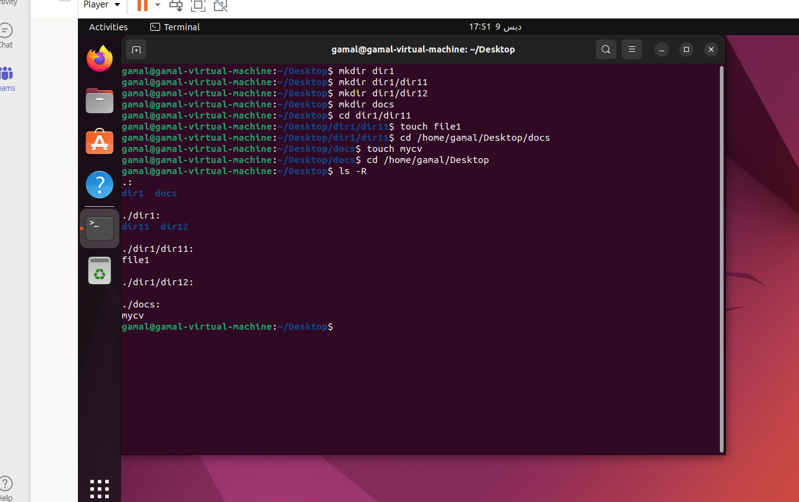

**a. Remove dir11 in one-step. What did you notice? And how did you overcome that?**

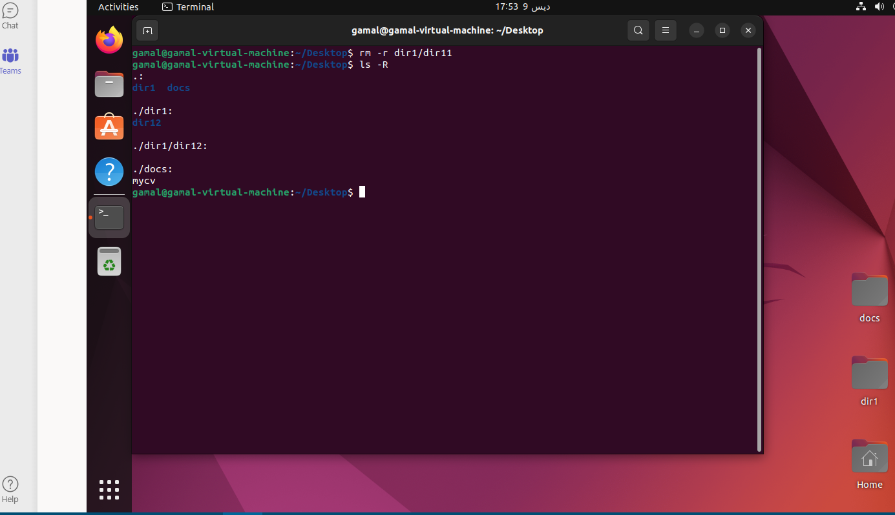

**b. Then remove dir12 using rmdir –p command. State what happened to the hierarchy (Note: you are in your home directory).**

I tried to find the equivalent command in ubuntu rm –f



what happened that it removes all ancestors of the directory

**c. The output of the command pwd was /home/user. Write the absolute and relative path for the file mycv**

Absolute path: cd /home/gamal/Desktop/docs

Relative path: cd Desktop/docs

**5. Copy the /etc/passwd file to your home directory making its name is mypasswd.**

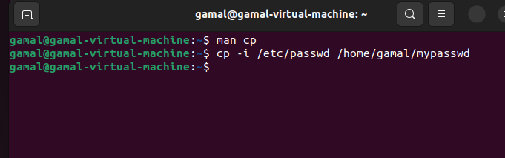

**7. You are in /usr/bin, list four ways to go to your home directory**

1. cd /home/gamal

2. cd ../../home/gamal

3. cd ~

4. cd

**9. Display the first 4 lines of /etc/passwd**

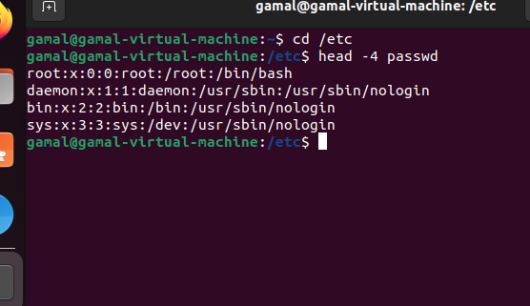

**10. Display the last 7 lines of /etc/passwd**

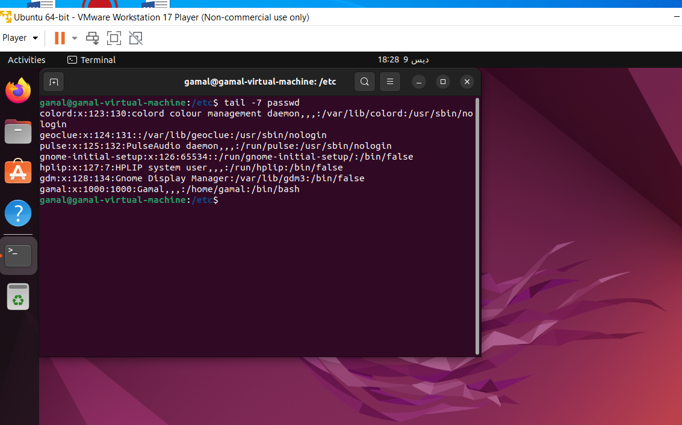

**11. Display the man pages of passwd the command and the file sequentially in one command.**

man -a passwd

**12. Display the man page of the passwd file.**

man -s5 passwd

**13. Display a list of all the commands that contain the keyword passwd in their man page.**

man -k passwd